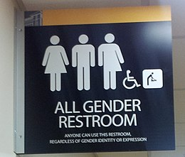
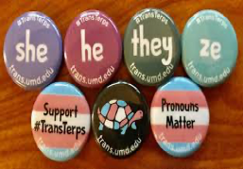

Insert college logo here
This Photo by Unknown Author is licensed under CC BY-SA-NC
This Photo by Unknown Author is licensed under CC BY-SA

Day of Dialogue 2020

Discussion Guide
  - Gender Identity & Expression

Introduction
Every March, AAWCC organizes its annual Day of Dialogue to encourage chapters to engage in thoughtful conversation about issues impacting women attending and working at community colleges. AAWCC develops a theme and toolkit to support chapters in developing programming that complements the theme. While called Day of Dialogue, chapter programming takes place throughout the month of March.  In 2020 we explore our role in advancing gender identity equity. The Board of Directors believe that as a leading national women’s organization, AAWCC must speak to the iniquities faced by students, faculty, and staff in our LGBTQ+ communities. We know that that for some, this is a personal and controversial topic and we need to lead campuses in having civil conversations on this topic. Join us to showing the nation how to lead with equity and civility on any sensitive topic. |  | Resources for Education & Action  ACPA Coalition for Sexuality and Gender Identities  Human Rights Campaign Resources  National LGBTQ Task Force  The Trevor Project  Teaching for Tolerance: Writing for Change  Pride Pocket: Gender Identity 101  Why use pronouns at work

National Picture of Discrimination of the LGBTQ+ Community
(Sources: Human Rights Campaign; ¹Discrimination in America (2017), Robert Wood Johnson Foundation & Harvard T.H. Chan School of Public Health, for NPR)
“At least one in five LGBTQ people report being personally discriminated against because of their sexuality or gender identity when applying for jobs (20%), when being paid equally or considered for promotion (22%), or when trying to rent a room or apartment or buy a house (22%)”¹ |  | Housing  - 21 States + D.C .prohibit discrimination based on sexual orientation and gender identity.  - 1 state prohibits discrimination based on sexual orientation only.

Employment
• 21 States + D.C. prohibit discrimination based on sexual orientation and gender identity.1
- 1 state prohibits discrimination based on sexual orientation only
- 7 states prohibit discrimination against public employees based on sexual orientation and gender identity
- 4 states prohibit discrimination against public employees based on sexual orientation only

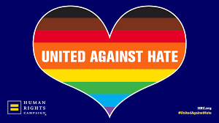 |  | Hate Crimes  - 20 states + D.C. address hate or bias crimes based on sexual orientation and gender identity  - 11 states address hate or bias crimes based on sexual orientation only

Education
- 15 states + D.C. address discrimination against students based on sexual orientation and gender identify
- 2 states address discrimination against students based on sexual orientation only
“Thirty-four percent of all LGBTQ people say that they or an LGBTQ friend or family member have been verbally harassed in the bathroom or been told or asked if they were using the wrong bathroom.” ¹ |  | Public Accommodations  - 20 states + D.C. prohibit discrimination based on sexual orientation and gender identity  - 1 state prohibits discrimination based on sexual orientation only
Transgender Health Care  - 6 states ban insurance exclusions for transgender health care  - 13 states + D.C. both ban on insurance exclusions for transgender healthcare and provide transgender inclusive health benefits for state employees |  | “Nearly a quarter [Transgender Americans] say they have avoided doctors or health care out of concern they would be discriminated against (22%), and 31% say they have not regular doctor or form of health care.”¹
Anti-conversion therapy  18 states + D.C. protect youth from so-called “conversion therapy” |  | Gender Marker Updates on ID Docs  - 20 states facilitate gender marker update on driver’s licenses only  - 12 states + D.C. facilitate gender marker update on both birth certificates and driver’s licenses
How does your state stack up?

Learn the Lingo
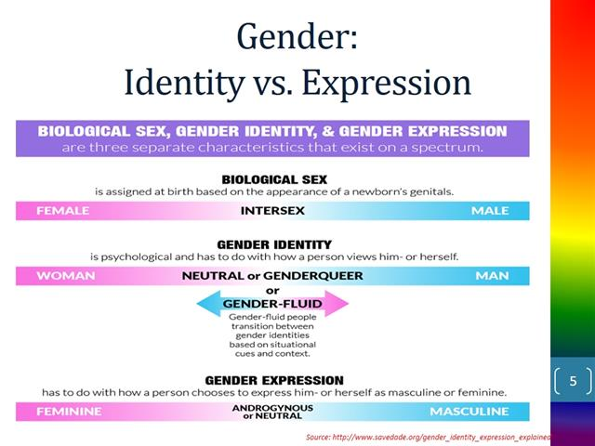

Gender Definitions
Gender: The state of being male or female in typically regarding to social constructs rather than physical attributes.
Cisgender: Refers to someone who identifies with the gender they were assigned at birth.
Gender Fluid: Refers to someone whose gender identity changes over time from one of the spectrum to the other.
Transgender: Refers to someone who does not identify with the gender they were assigned at birth.
Non-binary: Refers to someone who does not identify as exclusively male or female.
Genderqueer: Refers to someone whose gender identity falls on the spectrum between male and female.

(Definitions from "Non-Binary Identities 101" at pridepocket.com)

Discussion Questions for

your Chapter

Ideas for Action
Move from conversation to action! What can your AAWCC chapter do to support non-gender binary staff and students? Below are a few ideas to help get you started on your campus.

Pronouns - They matter!
- When doing introductions, include pronouns.
- Add pronouns to business cards, name tags, and email signatures.
Preferred or Chosen Names
- Enable the student records systems to show preferred or chosen names on class rosters to respect identify and to ensure faculty do not “out” non-binary students.
- Ensure that learning management systems show preferred or chosen names.
Create a Welcoming Environment
- Commit to establishing gender neutral restrooms in each building on campus.
- Celebrate Pride month while you are session.
- Establish a Gender Equity Center.
- Use inclusive language on websites and resources.
Review Policy & Practices
- Introduce a trans-inclusive policy.
- Include LGBTQ+ housing options and resources.
- Review all policies and contracts for gender-binary language.
- Ensure contractors are LBTQ+ friendly.
Advocate & Lobby
- 3 Ways to Advocate for Transgender People (ACLU).
- Attend a higher education conference on LGBTYQ+ .

- What barriers are faced by LGBTQ+ students, faculty, and staff at your college?
- What data do we have on LGBTQ+ college community members (students and employees)?
- What are the pros/cons of adding a gender identity question on student applications?
- What is the college’s role in advancing equity and inclusion for the LGBTQ+ community? How does this work align with our other equity and inclusion work?
- How can we structure civil conversations around difficult topics across our campus?

Share Out your Dialogue and Action
We want to share the good work happening on our campuses. During your Day of Dialogue, take some pics to share on Facebook or at #AAWCC and #dayofdialogue.
Report out your Day of Dialogue event to the National Office

Resources for Civil Conversations on Campus

Guidelines for Discussing Difficult or Controversial Topics

Informed Civic Engagement Resource Guide: Civil Discourse

Tips for Facilitating Challenging Conversations

